- Restart the device
- Enter the device IP in the browser to log in
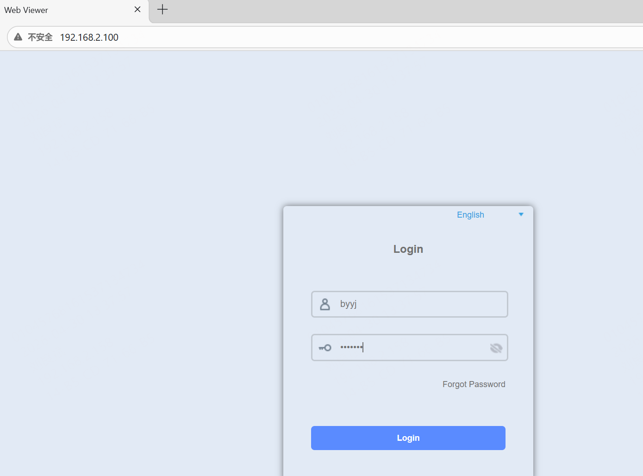
- Tick the ONVIF check in Remote Setting > System > Network.
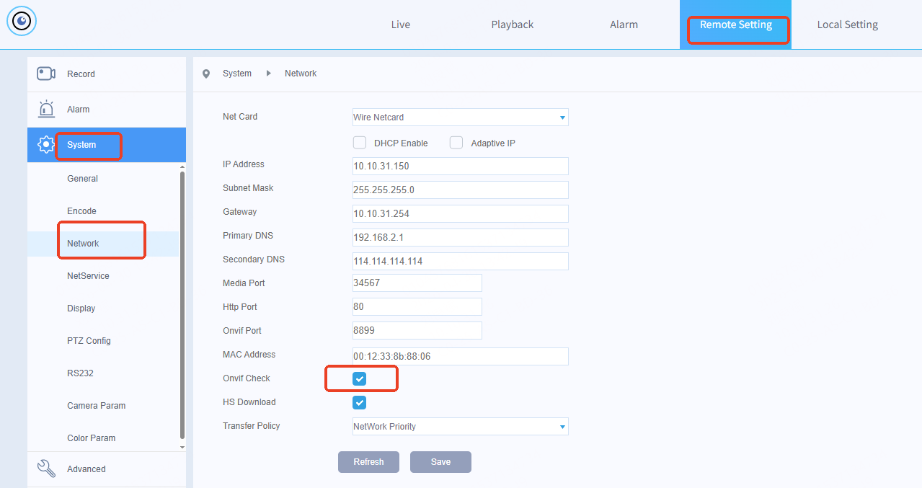
- Click Save and confirm to reboot the device.
